Network Quality Levels

Room SID :- RMbbb8050f3d9abadc004f0f5ecc19053e

Recording SID :- RT99fbedfcddc76671180afdec11ba1ed7

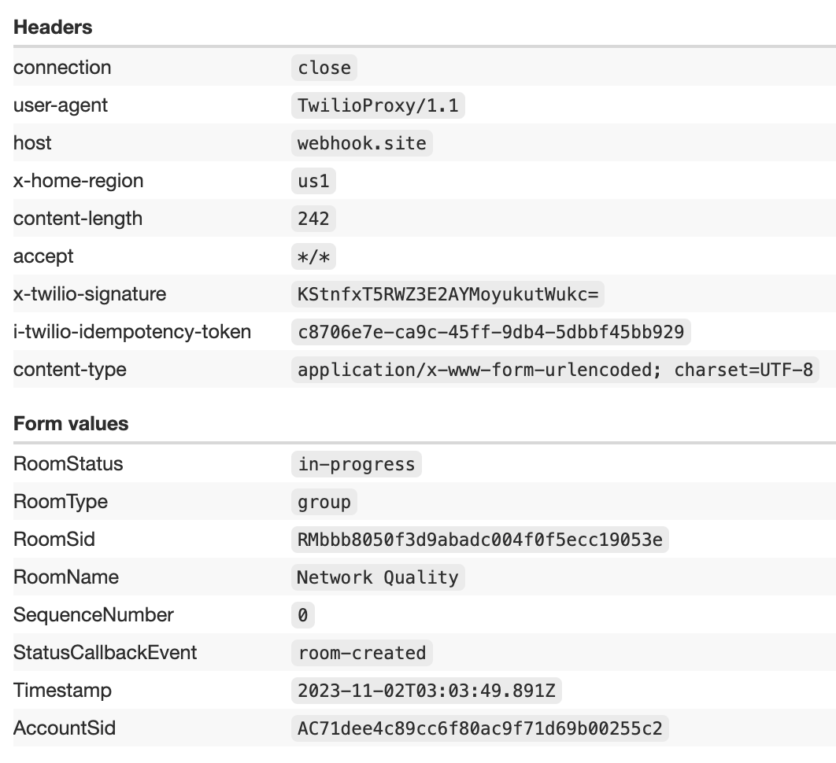

Alice  
Room SID :- RMda235220501f1761164d19fa3009ab6a

Recording SID :- RT2adfa1cae0c57c3ca92345255a236156

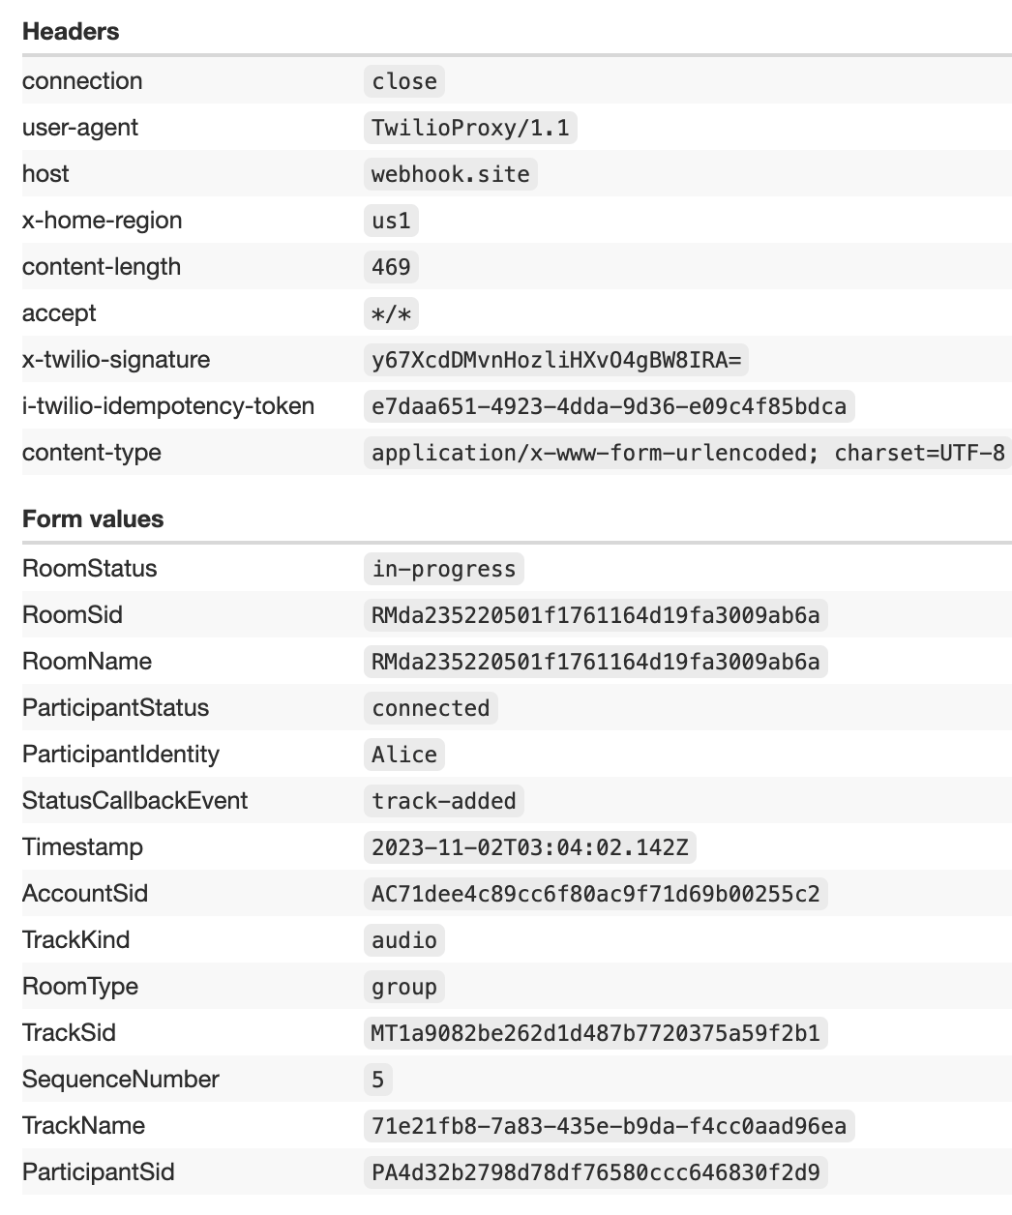

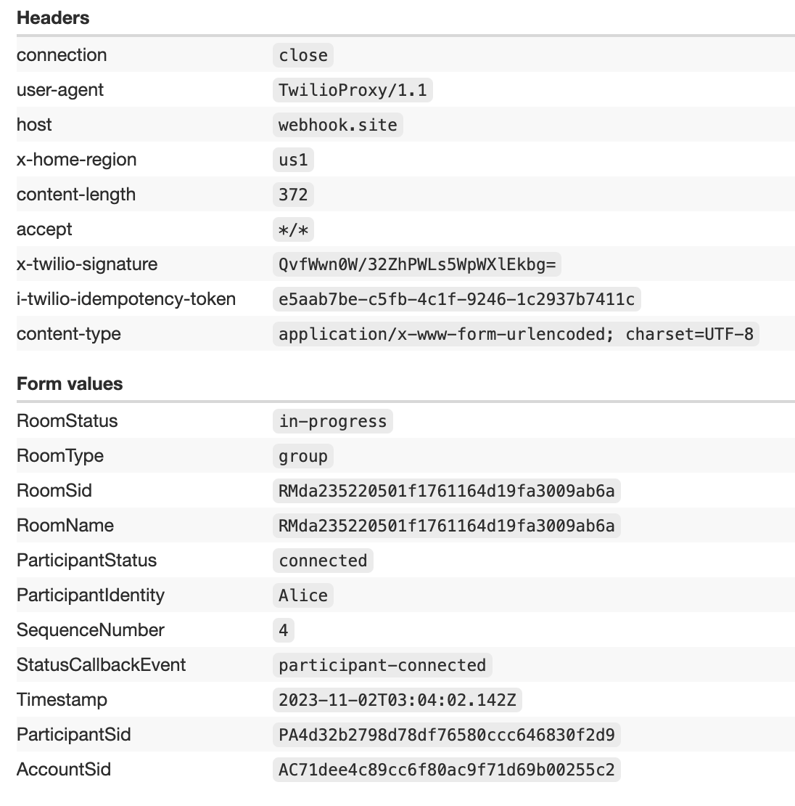

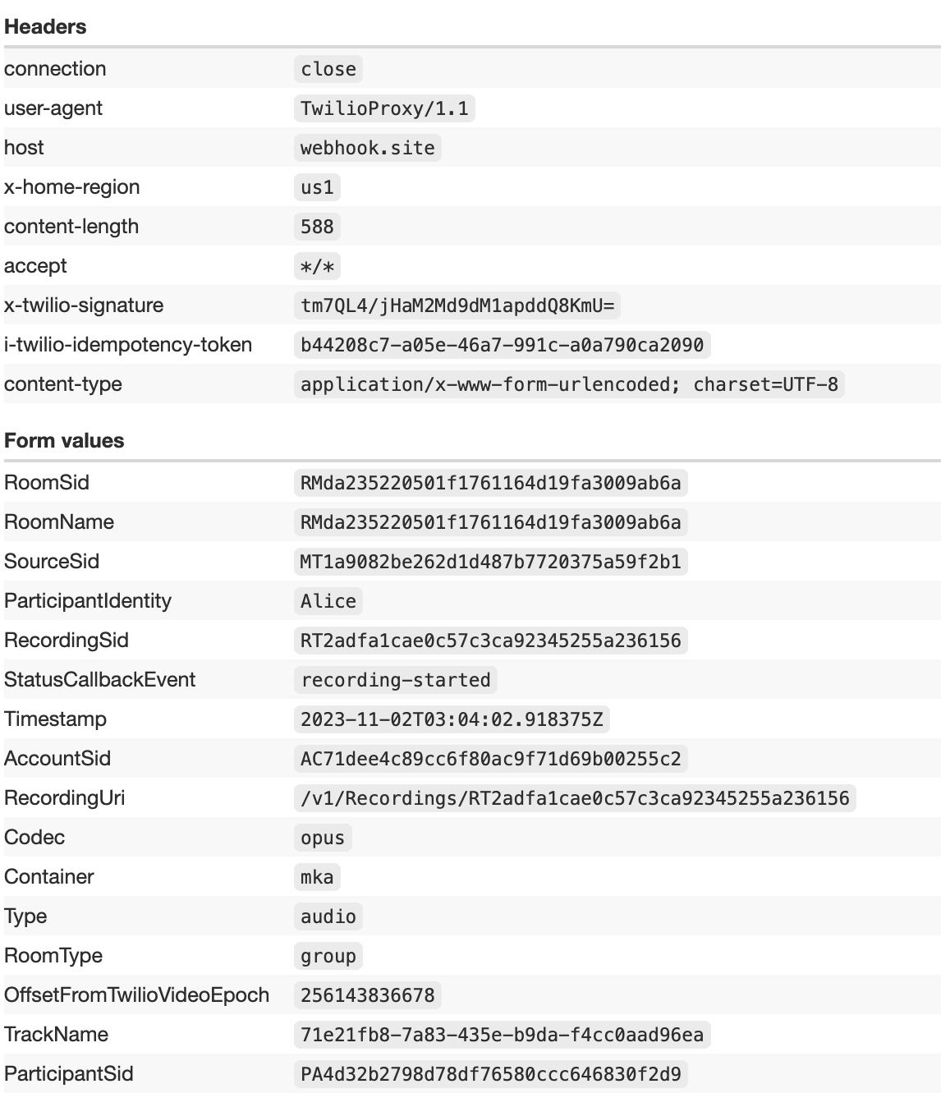

Mark

Recording SID :- RT43c1bda54114844c89e838a8adc46890

Room SID :- RMda235220501f1761164d19fa3009ab6a

